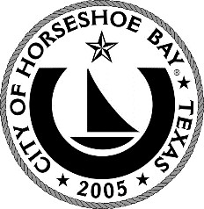
City of Horseshoe Bay
MARCH 18, 2025

To: Mayor and City Council Thru: Jeff Koska, City Manager
Re: Proclamation Declaring the Mayor’s Monarch Pledge

The City of Horseshoe Bay has made protecting the environment a priority. Part of our effort in that area has been participation in the Mayor’s Monarch Pledge, a national effort by the National Wildlife Federation to preserve the Monarch butterfly, which has suffered a sharp decline in population numbers during the last 25 years.

Biologists say possible reasons for the decline include destruction of habitat, improper use of pesticides, and climate change. The decline is such that the butterfly has been recognized as a candidate for being listed as a threatened species by the U.S. Fish and Wildlife Service.

The City joined the pledge five years ago under the guidance of previous Mayor Steve Jordan. One of the requirements of continued participation is that we renew the pledge annually, which is the purpose of today’s proclamation.

By taking the pledge we promise to take part in activities which will promote the Monarch’s survival. These include education of residents, milkweed and nectar plant seed giveaways, altered mowing schedules to protect breeding habitat, and the promotion of Monarch-friendly gardens being planted in our City.

The Mayors’ Monarch Pledge serves as a key component of the City’s work to enhance the environment. Other examples are: the Dark Skies Community designation, the development of the HSB Nature Park and efforts by the Utility Department to move honeybee hives which turn up in our water meter boxes.

For this reason, staff has brought this proclamation to the City Council to mark another year of participation in the Mayor’s Monarch Pledge.

Enclosures: Proclamation

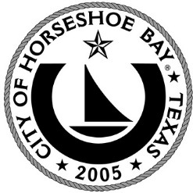

Proclamation Reaffirming Participation in the Mayors’ Monarch Pledge for 2025

WHEREAS, the monarch butterfly is an iconic North American species whose multi- generational migration and metamorphosis from caterpillar to butterfly has captured the imagination of millions of Americans; and
WHEREAS, scientists have documented a significant decline in the population of the monarch butterfly, an important pollinator species which each year migrates through Central Texas; and
WHEREAS, the population decline is such that the monarch has become a threatened species. Eastern populations have declined by 90% and western populations have declined by 99% in recent years; and
WHEREAS, local governments have a critical role to play to help protect the monarch butterfly; and
WHEREAS, the National Wildlife Federation offers a way for the City to help boost monarch numbers through its nationwide Mayors’ Monarch Pledge and list of action steps on their website at https://www.nwf.org/mayorsmonarchpledge; and
WHEREAS, the City of Horseshoe Bay, a participant in the monarch pledge, continues to play a leadership role through education, by encouraging the planting of native milkweed and flowering plants, mowing delays and other efforts to help the monarch; and
WHEREAS, every citizen of Horseshoe Bay can make a difference for the monarch and other pollinators by creating or protecting habitat at our homes, businesses and public spaces.

NOW, THEREFORE, I, Elsie Thurman, Mayor of the City of Horseshoe Bay, do hereby proclaim and reaffirm the City’s participation in the Mayors’ Monarch Pledge for 2025.

City of Horseshoe Bay

Mayor Elsie Thurman

